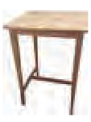
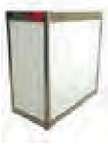
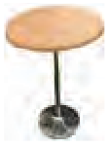
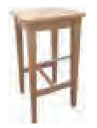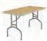ENHANCE YOUR STAND
Square Top Wooden High Table
White Top Meeting Table
Length:1600mm x Width:800mm

Wooden High Stool

Chrome Frame Stool with black seat

750mm Round Table
Wood Top with Chrome Base

6’x2’
Trestle table

White Open Back Counter
1mt x 1mt x 500mm
50 L
Swing Top Bin Grey

Rectangular Coffee Table
black / brown

High Table
1110mm
...................................................

F U R N I T U R E
...................................... HIRE
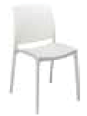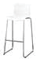

Upholstered Chair
€20.00
1

White Chair

€20.00
2
Roma Bucket
Chair White
W 59cm x D 56cm x H 73cm

€34.00
3

Milano Chair
Black
€45.00
4

White Stool
€65.00

5

€45.00 | €40.00 | €40.00 | €22.00 | €38.00
6 | 7 | 8 | 9 | 10

€35.00 | €22.00 | €40.00 | €80.00 | €25.00
11 | 12 | 13 | 14 | 15

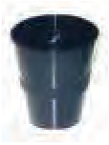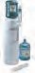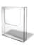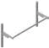

Fridge
€140.00

16

Waste Paper Bin
€7.65

17
A4 Setup Literature Holder
€65.00
18
Water Cooler
with 2 water bottles & cups supplied
€160.00
19

A4 Literature Holder
€10.00
20
Velcro 1m
€6.50
21
Shelf White Wooden
SLOPING
L 100cm x W 30cm
€45.00
22
Shelf White Wooden
STRAIGHT
L 100cm x W 30cm
€45.00
23

Hanging Garment Rails
€38.40
24

Slatwall White
€75.00

25
White Shelving Unit
€38.00
26
tel 01 456 1011
web www.wdisplay.com email sbell@wdisplay.com
Unit 12/13 Crumlin Business Centre, Stannaway Drive, Crumlin, Dublin 12

* Some Items may vary from the illustration shown ** Prices subject to VAT are for duration of the show

All Orders must be paid in full before work will commence on your requirements
Note: Unfortunately we cannot offer refunds onsite. Shortage must be reported onsite.
W Display Furniture Order Form 2022

Please complete this form and return with full payment immediately to:
W DISPLAY, Unit 12/13 Crumlin Business Centre, Stanaway Drive, Crumlin, Dublin 12
Tel: 353 (0) 1 4561011
Contact: Suzanne Bell E-mail: sbell@wdisplay.com

No | ITEM | PRICE | QUANTITY | TOTAL
1 | Upholstered Chair | €20.00
2 | White Chair | €20.00
3 | Roma Bucket Chair | €34.00
4 | Milano Chair Black | €45.00
5 | White Stool | €65.00
6 | Wooden High Stool | €45.00
7 | Chrome Frame Stool with Black Seat | €40.00
8 | Square Top Wooden High Table | €40.00
9 | 750mm Round Table - Wood Top with Chrome Base | €22.00
10 | High Table | €38.00
11 |  | €35.00
12 | 6’ x 2’ Trestle Table | €22.00
13 | Rectangular Coﬀee Table - Black / Brown | €40.00
14 | White Open Back Counter - 1m x 1m x 500mm | €80.00
15 | 50l Swing Top Bin Grey | €25.00
16 | Fridge | €140.00
17 | Waste Paper Bin | €7.65
18 | A4 Setup Literature Holder (Rental Price) | €65.00
19 |  | €160.00
20 | A4 Literature Holder | €10.00
21 | Velcro 1m | €6.50
22 | Shelf - White Wooden Sloping - 1m long x 300mm wide | €45.00
23 | Shelf - White Wooden Straight - 1m long x 300mm wide | €45.00
24 | Hanging Garment Rails | €38.40
25 | Slatwall White | €75.00
26 | White Shelving Unit | €38.00
SUB TOTAL VAT @ 23%
TOTAL

PLEASE NOTE:
- Orders are only considered confirmed once invoice has been issued and full payment received.
- Furniture will not be delivered to stands until full payment has been received.
- Unfortunately we cannot offer refunds onsite. Shortages must be reported onsite.

Contact name:

E-mail address for invoice:
VAT No if based outside of ROI:

Payment can be made in two ways:
1.

2. By credit or debit card. To pay by this method, please contact the W Display oﬃce on 01 456 1011 and a member of our accounts team will process your payment.

